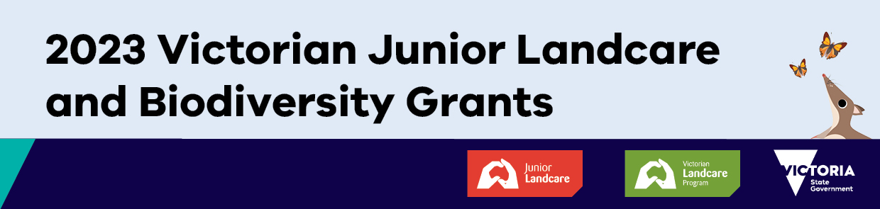
Newsletter article template announcing your 2023 Victorian Junior Landcare and Biodiversity Grant

The highlighted text is where you can add more detail about your school or organisation and project.

We’re excited to announce that our name of school, club, etc. is one of 123 childcare centres, schools, Scouts and Girl Guides groups, and youth groups to receive a 2023 Victorian Junior Landcare and Biodiversity Grant.

Delivered through Landcare Australia’s Junior Landcare program, and funded by the Victorian Government, the grants provide young people with the opportunity to engage in outdoor, hands-on biodiversity focused projects or learning activities that encourage them to value and actively care for Victoria’s biodiversity and natural environment.

We are using our $xxxx grant for our (insert name of your project) project.

Place a brief description of your project here. You may want to add a sentence about the project’s expected environmental and/or educational outcomes.

The Victorian Junior Landcare and Biodiversity Grants are funded by the Victorian Government through the Department of Energy, Environment and Climate Action. They contribute to the targets of Protecting Victoria’s Environment – Biodiversity 2037, the Victorian Government’s plan to stop the decline of our native plants and animals and improve our natural environment.

You may want to include a photo of children who will be involved in the project and who have permission to be photographed, or you can use below graphic in your newsletter story.

Click here to download a graphic from the Victorian Junior Landcare Biodiversity Grants Promotional Kit website.

