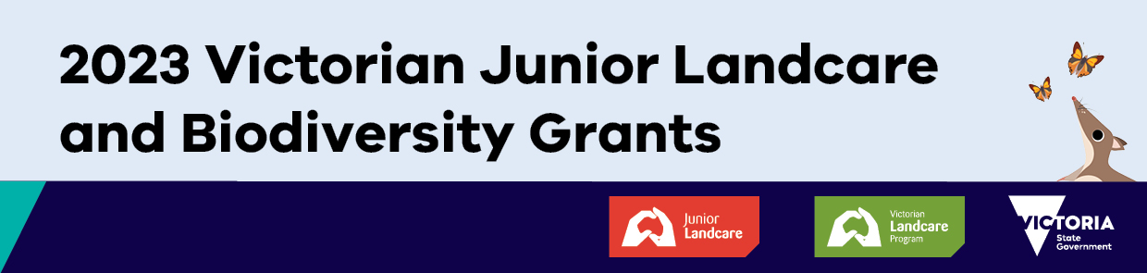
Media Release template for your school or organisation to announce your 2023 Victorian Junior Landcare and Biodiversity Grant

Photo: Your local print or online newspaper is more likely to publish a media release if you include a photo (1-5MB) with a few of the children who will be involved in the project. Remember to show faces in the photo and only use photos of children whose guardians have signed an image release form!

Yellow indicates where to personalise your release

Media Release

School or organisation name receives a 2023 Victorian Junior Landcare and Biodiversity Grant

School or organisation name is one of 123 schools and youth organisations to receive a 2023 Victorian Junior Landcare and Biodiversity Grant.
Delivered through Landcare Australia’s Junior Landcare program, and funded by the Victorian Government, the grants provide young people the opportunity to engage in outdoor, hands-on biodiversity focused projects or learning activities that provide both environmental and educational outcomes.

Write a paragraph summarising your project – the below paragraph is an example to be replaced with your own information:

Our grant of $..... will be used for a Hive Biodiversity Project with the aim of drastically increasing the school’s biodiversity by planting a range of native plant species which will in turn provide food species and habitat for native insects and birds. The outdoor environment will also provide an opportunity for birds and insects using nest boxes, bug houses and log piles.

You can include your own quote here. This is an example: “We are delighted to receive a Victorian Junior Landcare and Biodiversity Grant and are eager to start our project. Our students will learn about improving our soil, increase biodiversity through native planting and apply land care principles to promote ongoing support for native wildlife,” said name and title of principal, teacher, or someone else from your organisation.

Funded by the Victorian Government through the Department of Department of Energy, Environment and Climate Action, the grants also contribute to the targets of Protecting Victoria’s Environment - Biodiversity 2037, the Victorian Government’s plan to stop the decline of our native plants and animals and improve our natural environment.

For more information about the 2023 Victorian Junior Landcare and Biodiversity Grants, visit: 2023 Victorian Junior Landcare and Biodiversity Grants | Junior Landcare

For more information about the Victorian Government’s plan Protecting Victoria’s Environment – Biodiversity 2037, visit environment.vic.gov.au/biodiversity/biodiversity-plan

Media contact: Add contact details for someone at your school or organisation—name, email and phone number.

About Junior Landcare and the Victorian Junior Landcare and Biodiversity Grant Program
Launched in 1998, Junior Landcare is an awareness raising and funding program that encourages children and young people to play an active role in ensuring the safe future of the environment. Since the Victorian Junior Landcare and Biodiversity Grants were introduced in 2018, 678 projects have received $2,496,703 in funding from the Department of Energy, Environment and Climate Action, up to and including 2023. The grants provide funding to Victorian primary and secondary schools, kindergartens, preschools, childcare centres, Scouts, Girl Guides and Junior Landcare groups for projects that involve and educate young people in valuing and actively caring for Victoria’s biodiversity and natural environment.

