Sample template to use for newsletter article or on your website announcing your Woolworths Junior Landcare grant

We suggest you use the below graphic with your article—you might also want to include a photo of the children who will be participating –maybe already at work on the project! Yellow indicates where you should personalise.

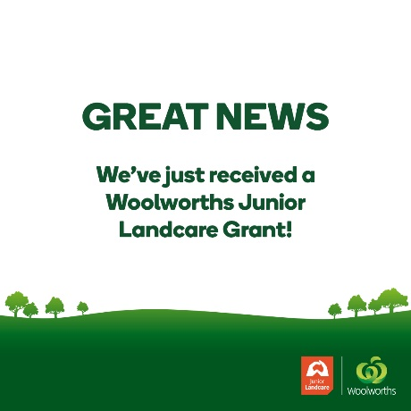
If you haven’t already downloaded this graphic, please click the below link to download now

We’ve been successful with our application for a Woolworths Junior Landcare Grant for our project, insert the name of your project!

You may want to add a couple sentences about what students will be participating and the project’s expected environmental and/or educational outcomes.

(School or early learning centre name) is one of 617 primary schools and early learning centres throughout Australia receiving a Woolworths Junior Landcare grant to help grow our next generation of environmental champions.

The grants are being funded with money made from the sale of the Woolworths recyclable Bag for good™ which was launched in 2018 when the supermarket stopped using single-use plastic bags.

The children and teachers are looking forward to working and learning from this project and we’ll keep you updated on the results.

Click on the Woolworths Junior Landcare Grant map to read about our project and others.

*the link to the entire map is: https://landcareaustralia.org.au/woolworthsgrants/maps
Or, if you want to just link to your school’s project, click on the big map, find your project and then cut and past the URL into this article and create a hyperlink.

